**HTML Task to know usage of basic tags.**

**2. Try the below one**

<html lang="en">

<head>

<title>Document

<body>

guvi

</head>

<div>

Lorem ipsum dolor sit amet consectetur adipisicing elit.

<div>

<div>

Guvi Geek Network

</div>

</body>

</html>

**Bugs in the above code:**

* The body tag should be comes after the head tag.
* The title tag has not been closed.
* And a div tag is not closed at the line no.10

**Corrected Code:**

<html lang="en">

<head>

<title>Document</title>

</head>

<body>

guvi

<div>

Lorem ipsum dolor sit amet consectetur adipisicing elit.

<div>

</div>

Guvi Geek Network

</div>

</body>

</html>

**Output:**

guvi

Lorem ipsum dolor sit amet consectetur adipisicing elit.

Guvi Geek Network

**1.Fix the bugs in below snippet**

<html lang="en">

<head>

<title>Document

<body>

guvi

</title>

</head>

<div>

Lorem ipsum dolor sit amet consectetur adipisicing elit.

<div>

<div>

Guvi Geek Network

</div>

</body>

</html>

**Bugs in the above code:**

* The body tag should be comes after the head tag.
* And a div tag is not closed at the line no.10

**Corrected Code:**

<html lang="en">

<head>

<title>Document

</title>

</head>

<body>

guvi

<div>

Lorem ipsum dolor sit amet consectetur adipisicing elit.

</div>

<div>

Guvi Geek Network

</div>

</body>

</html>

**Output:**

guvi

Lorem ipsum dolor sit amet consectetur adipisicing elit.

Guvi Geek Network

**3.Design a contact us form with all fields as required.**

**HTML Code:**

<!DOCTYPE html>

<html lang="en">

<head>

    <meta charset="UTF-8">

    <meta http-equiv="X-UA-Compatible" content="IE=edge">

    <meta name="viewport" content="width=device-width, initial-scale=1.0">

    <title>Document</title>

    <link rel="stylesheet" href="style.css">

    <script src="script.js"></script>

    <style>

        .div2 {

          width: 300px;

          height: 300px;

          padding: 0px;

          border: 3px solid black;

        }

    </style>

</head>

<body>

    <div class="div2" id="wrapper">

        <div1 id="contact_form_div">

        <center> <h1 id="contact_label">CONTACT US</h1> </center>

         <form method="GET" action="">

          <center ><p id="contact_label">  <p>

            <td>Name:</td>

            <input type="text" placeholder="Enter Name"></p>

          <p>

            <td>Email:</td>

            <input type="email" placeholder="Enter Email"></p>

          <p>

            <td>Number:</td>

            <input type="number" placeholder="Enter Contact No"></p>

          <p>

            <td>Your message:</td>

            <textarea placeholder="Enter Message"></textarea></p>

          <p><input type="submit" value="SUBMIT"></p>

         </form>

        </div1> </center>

        </div>

</body>

</html>

**Output:**

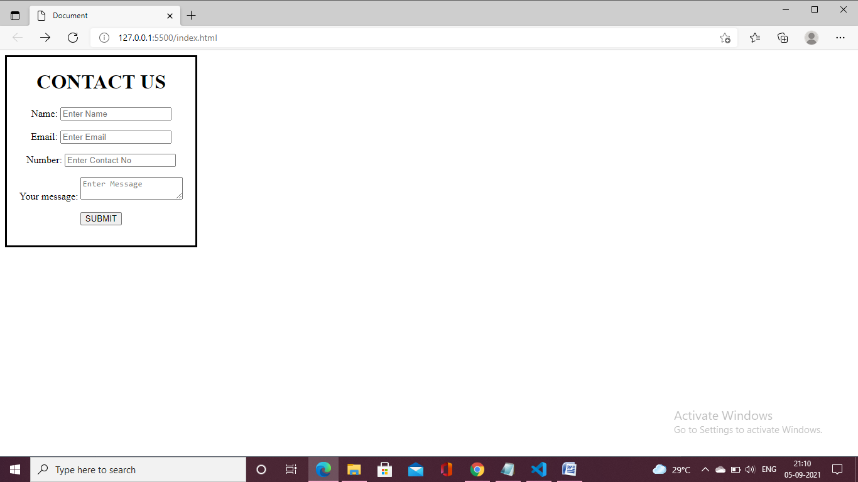

**4. Use certain HTML elements to display the following in a HTML page.**

HTML Code:

<!DOCTYPE html>

<html lang="en">

<head>

    <meta charset="UTF-8">

    <meta http-equiv="X-UA-Compatible" content="IE=edge">

    <meta name="viewport" content="width=device-width, initial-scale=1.0">

    <title>Document</title>

    <link rel="stylesheet" href="style.css">

    <script src="script.js"></script>

</head>

<body>

    <ul style="list-style-type:disc;">

        <li>Programming Language</li> <br/>

        <ul style="list-style-type:circle;">

           <li>JavaScript</li> <br/>

            <ol type="a">

             <li>Angular</li> <br/>

             <li>React</li> <br/>

             <li>Vue.js</li> <br/>

            </ol>

        </ul>

        <ul style="list-style-type:circle;">

           <li>Python</li> <br/>

           <ol type="a">

               <li>Django Framework</li> <br/>

               <li>Flask Framework</li> <br/>

           </ol>

        </ul>

        <ul style="list-style-type:circle;">

           <li>Java</li> <br/>

           <ol type="a">

               <li>Spring</li> <br/>

               <li>Maven</li> <br/>

               <li>Hibernate</li> <br/>

           </ol>

        </ul>

       </ul>

    <ul style="list-style-type:disc;">

       <li>Database</li> <br/>

       <ul style="list-style-type:circle;">

          <li>MySQL</li> <br/>

          <li>MongoDB</li> <br/>

          <li>Cansandra</li> <br/>

       </ul>

   </ul>

</body>

</html>

Output:

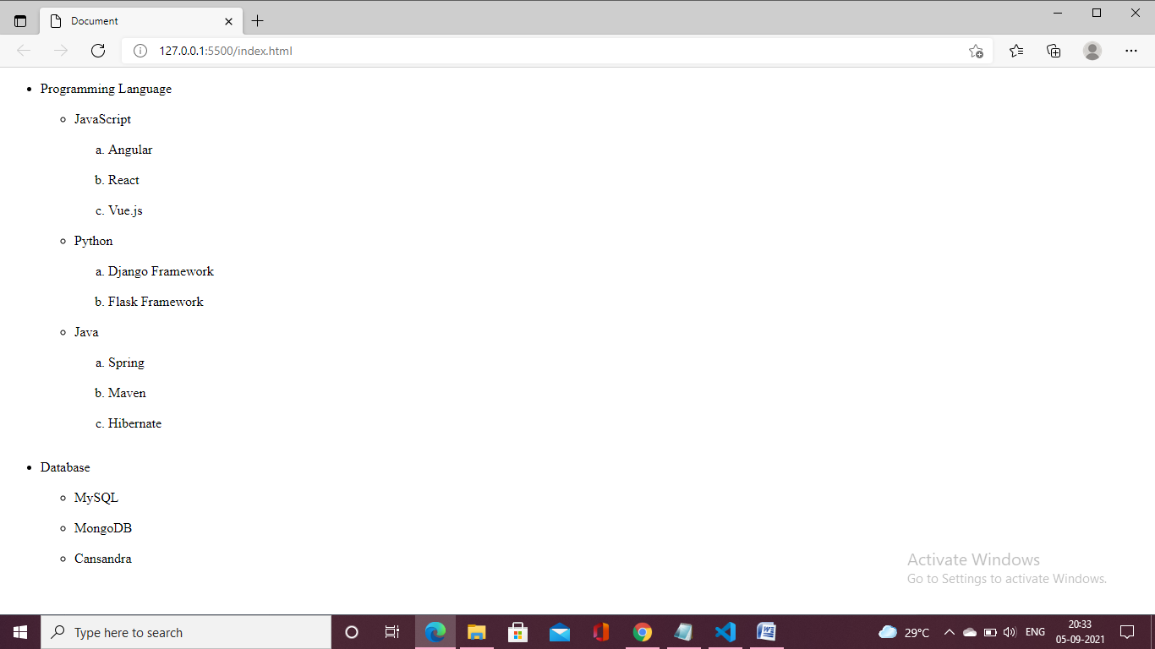

**5.Create an element that helps you to open the**[**https://google.com**](https://google.com/)**in separate new tab.**

**HTML Code:**

<!DOCTYPE html>

<html lang="en">

<head>

    <meta charset="UTF-8">

    <meta http-equiv="X-UA-Compatible" content="IE=edge">

    <meta name="viewport" content="width=device-width, initial-scale=1.0">

    <title>Document</title>

    <link rel="stylesheet" href="style.css">

    <script src="script.js"></script>

</head>

<body>

    <h1>HTML Links</h1>

<p><a href="https://google.com" >Visit The Google.com!</a></p>

</body>

</html>

**Output:**

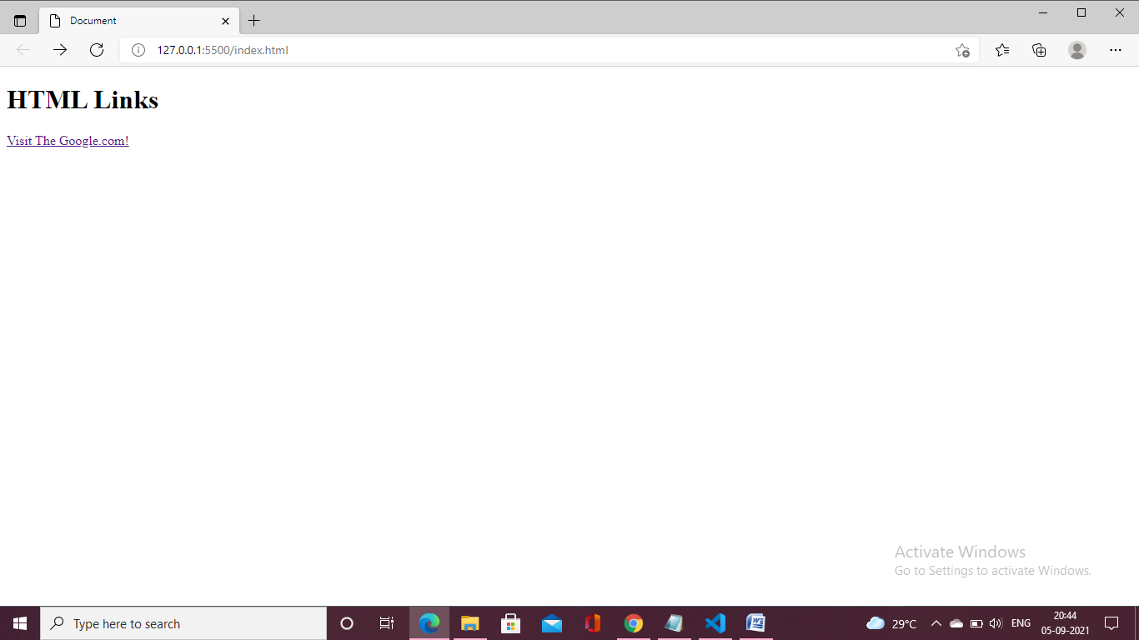

6.**In the form, add two radio buttons with grouping them for employee type(Salaried and own business)**

**HTML Code:**

<!DOCTYPE html>

<html lang="en">

<head>

    <meta charset="UTF-8">

    <meta http-equiv="X-UA-Compatible" content="IE=edge">

    <meta name="viewport" content="width=device-width, initial-scale=1.0">

    <title>Document</title>

    <link rel="stylesheet" href="style.css">

    <script src="script.js"></script>

    <style>

        .div2 {

          width: 350px;

          height: 300px;

          padding: px;

          border: 3px solid black;

        }

    </style>

</head>

<body>

    <div class="div2" id="wrapper">

        <center> <h1>Employee Details </h1>

         <form method="GET" action="">

          <p id="contact_label">

            <td>First Name:</td>  <input type="text" > <br> <br>

            <td>Last Name:</td>   <input type="text"> <br> <br>

            <td>Address:</td>  <input type="textb" > </p>

            <td>Employee Type:</td>

              <INPUT TYPE="Radio"  Name="format">Salaried

              <INPUT TYPE="Radio"  Name="format">Own business

            </p>

          <p><input type="submit" value="Submit"></p>

         </form>

        </div1>

        </div>

</body>

</html>

**Output:**

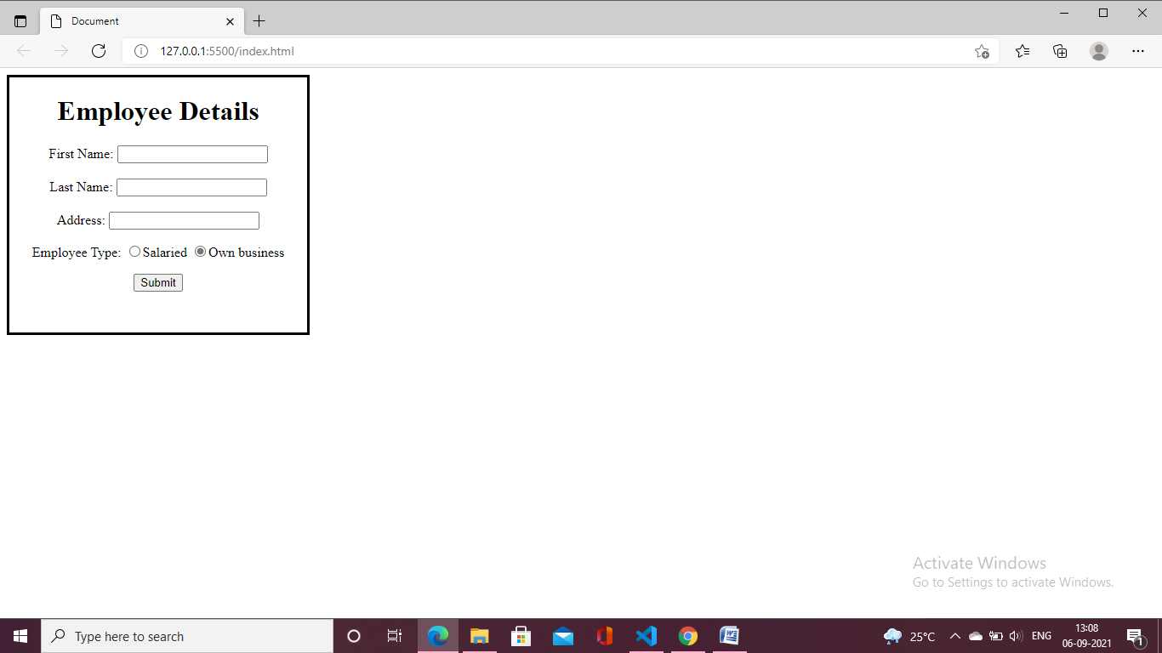

1. **Design form shown in the link (**[**http://evc-cit.info/cit040/formguide/card_0.png**](http://evc-cit.info/cit040/formguide/card_0.png)**)**

**HTML Code:**

<!DOCTYPE html>

<html lang="en">

<head>

    <meta charset="UTF-8">

    <meta http-equiv="X-UA-Compatible" content="IE=edge">

    <meta name="viewport" content="width=device-width, initial-scale=1.0">

    <title>Document</title>

    <link rel="stylesheet" href="style.css">

    <script src="script.js"></script>

    <style>

        .div2 {

          width: 700px;

          height: 350px;

          padding: 10px;

          border: 3px solid black;

        }

    </style>

</head>

<body>

    <div class="div2" id="wrapper">

        <div1 id="contact_form_div">

         <h1 style="background-color:red; color:white;">Yes! I want to subscribe to <i> Mag-O-Zine </i> </h1>

         <form method="GET" action="">

          <p id="contact_label">  <p>

            <td>First Name:</td>  <input type="text" >

            <td>Last Name:</td>   <input type="text"></p>

          <p>

            <td>Address:</td>

            <input type="text" ></p>

          <p>

            <td>City:</td>  <input type="text">

            <td>State:</td> <input type="text">

            <td>Zip:</td>  <input type="text"> </p>

            <p>

              <td>Subscribe for:</td>

              <INPUT TYPE="Radio"  Name="format">1 year ($19.95)

                <INPUT TYPE="Radio"  Name="format">2 years ($35.00)

            </p>

            <p>

              <td>Send me more information about:</td> </br>

              <INPUT TYPE="Checkbox" >Computer-Zine <br>

              <INPUT TYPE="Checkbox" >Fisher-Zine <br>

              <INPUT TYPE="Checkbox" >Cat-O-Zine

            </p>

          <p><input type="submit" value="Send"></p>

         </form>

        </div1>

        </div>

</body>

</html>

**Output:**

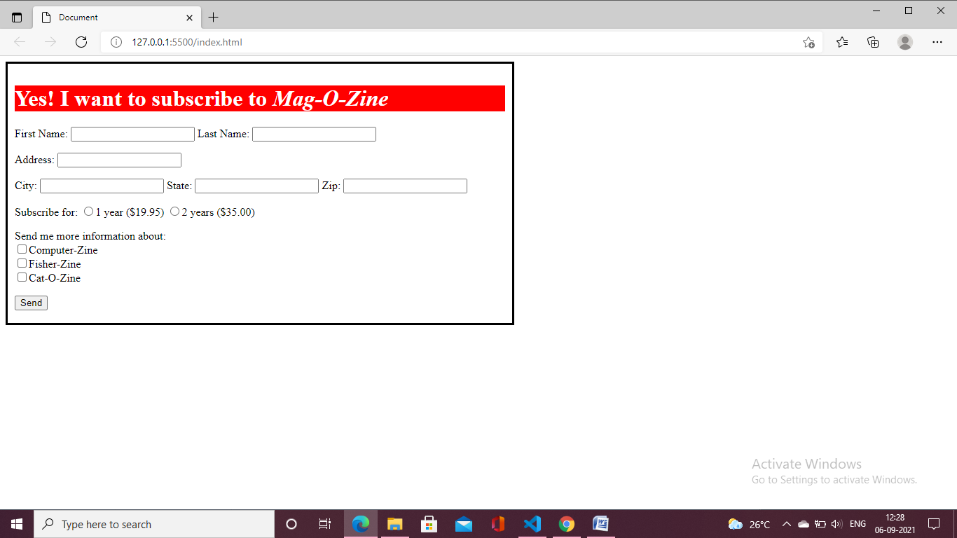

1. **Use the table tag to design given image**[**Click here**](https://www.bapugraphics.com/assets/img/port_upload_dir/table-4.jpg)**.**

**HTML Code:**

<!DOCTYPE html>

<html lang="en">

<head>

    <meta charset="UTF-8">

    <meta http-equiv="X-UA-Compatible" content="IE=edge">

    <meta name="viewport" content="width=device-width, initial-scale=1.0">

    <title>Document</title>

    <link rel="stylesheet" href="style.css">

    <script src="script.js"></script>

    <style>

      table,

      th,

      td {

        padding: 10px;

        border: 1px solid black;

        border-collapse: collapse;

      }

    </style>

</head>

<body>

    <table>

    <center> <caption>Health Chart </caption>

    <tr>

       <td rowspan="2">State of Health</td>

        <td colspan="2">Fasting Value</td>

        <td colspan="2">After Eating</td>

    </tr>

    <tr>

        <td>Minimum</td>

        <td>Maximum</td>

        <td>2 hours after eating</td>

    </tr>

    <tr>

        <td>Healthy</td>

        <td>70</td>

        <td>100</td>

        <td>Less than 140</td>

    </tr>

    <tr>

        <td>Pre-Diabetes</td>

        <td>101</td>

        <td>126</td>

        <td>140 to 200</td>

    </tr>

    <tr>

      <td>Diabetes</td>

      <td>More than 126</td>

      <td>N/A</td>

      <td>More than 200</td>

    </tr>

</table> </center>

</body>

</html>

**Output:**

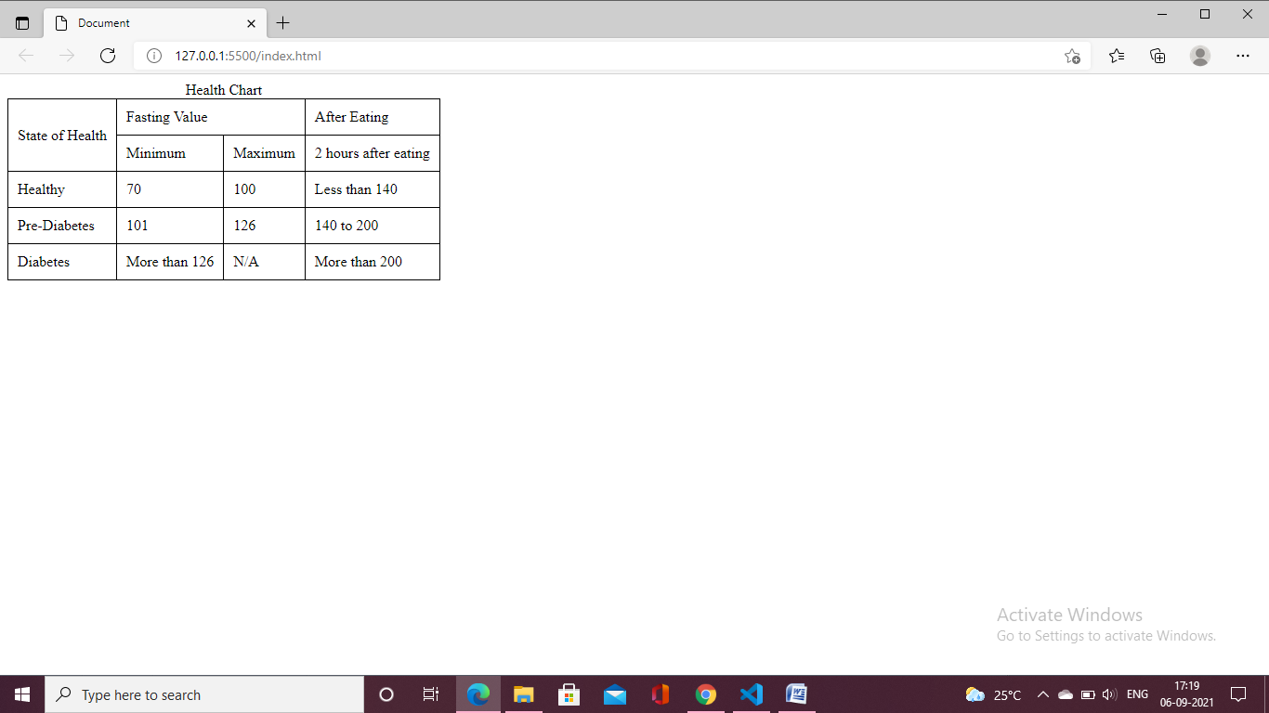

**9.Write HTML input tags snippet to show default values for all Form elements**.

* <input type="button">
* <input type="checkbox">
* <input type="color">
* <input type="date">
* <input type="datetime-local">
* <input type="email">
* <input type="file">
* <input type="hidden">
* <input type="image">
* <input type="month">
* <input type="number">
* <input type="password">
* <input type="radio">
* <input type="range">
* <input type="reset">
* <input type="search">
* <input type="submit">
* <input type="tel">
* <input type="text"> (default value)
* <input type="time">
* <input type="url">
* <input type="week">

**10.In your, HTML page add the below line and Highlight it without using any CSS.**

* "HTML & CSS is awesome"

**HTML Code:**

<!DOCTYPE html>

<html lang="en">

<head>

    <meta charset="UTF-8">

    <meta http-equiv="X-UA-Compatible" content="IE=edge">

    <meta name="viewport" content="width=device-width, initial-scale=1.0">

    <title>Document</title>

    <link rel="stylesheet" href="style.css">

    <script src="script.js"></script>

</head>

<body>

 <mark>"HTML & CSS is awesome"</mark>

</body>

</html>

**Output:**

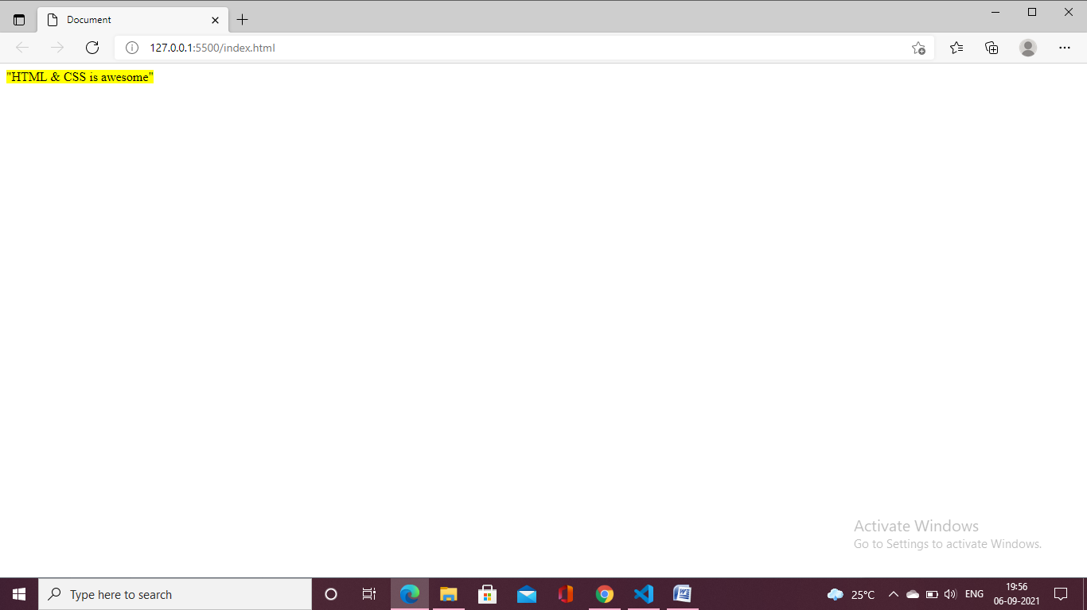

**11.Create an HTML page, which should contain all types of input elements.**

**HTML Code:**

<!DOCTYPE html>

<html lang="en">

<head>

    <meta charset="UTF-8">

    <meta http-equiv="X-UA-Compatible" content="IE=edge">

    <meta name="viewport" content="width=device-width, initial-scale=1.0">

    <title>Document</title>

    <link rel="stylesheet" href="style.css">

    <script src="script.js"></script>

</head>

<body>

  <input type="button">button <br>

  <input type="checkbox">checkbox <br>

  <input type="color">color <br>

  <input type="date">Date <br>

  <input type="datetime-local">Date time local <br>

  <input type="datetime">Date time <br>

  <input type="email"> Email <br>

  <input type="file"> File <br>

  <input type="hidden"> Hidden <br>

  <input type="image"> Image <br>

  <input type="month"> Month <br>

  <input type="number">Number <br>

  <input type="password">Password <br>

  <input type="radio">Radio button <br>

  <input type="range">Range <br>

  <input type="reset">Reset <br>

  <input type="search">Search <br>

  <input type="submit"> Submit<br>

  <input type="tel"> <br>

  <input type="text">Text <br>

  <input type="time">Time <br>

  <input type="url"> URL<br>

  <input type="week"> week

</body>

</html>

**Output:**

